Understanding Grunt file

# Chapter 1: Introduction

* For Angular newbies, Grunt is a task-runner tool, that does some repetitive tasks automatically on command.
* Prerequisites require for Grunt is available at its official site <https://gruntjs.com/getting-started>. You can go through it if you haven’t installed yet.
* Now, I am assuming that you have installed GRUNT CLI. After installation, your project is now configured with a Gruntfile.
* This Gruntfile is a javascript file, that will allow you to define those repetitive tasks. For each task, there might have some dependency. So, it is preferable to install them first and check whether they exist in package.json or not.
* So, I am here to make you understand that Gruntfile, that will help you to customize it as well as optimizing your angular project.
* Inside Gruntfile, you can define different tasks that are following,

1. You can compile different CSS preprocessor like SASS, LESS, STYLUS.
2. You can compile different template languages like PUG(previously known as JADE).
3. You can minify your CSS and javascript files.
4. You can copy that build minified project into a different directory.
5. You can clean any directory.
6. You can build your project, each time you make changes.
7. At the end, you can start development server.

Let’s start understanding gruntfile.js

Module.exports=function(grunt)

{

// All grunt related activity defined here.

};

1. This is a wrapper function that includes your grunt configuration and all tasks.

require(**'time-grunt'**)(grunt);

1. Display the elapsed execution time of [grunt](http://gruntjs.com/) tasks.

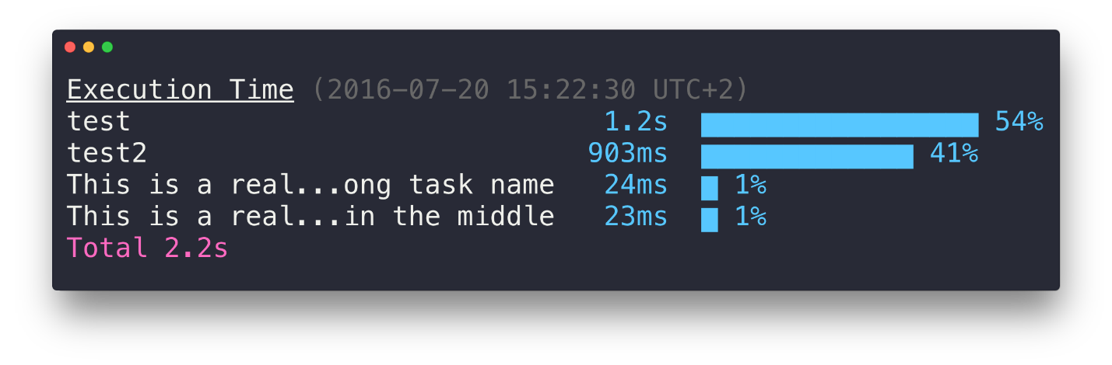

require(**'jit-grunt'**)(grunt, {  
 **…**});

1. A JIT(Just In Time) plugin is a loader for grunt. It loads grunt tasks automatically.

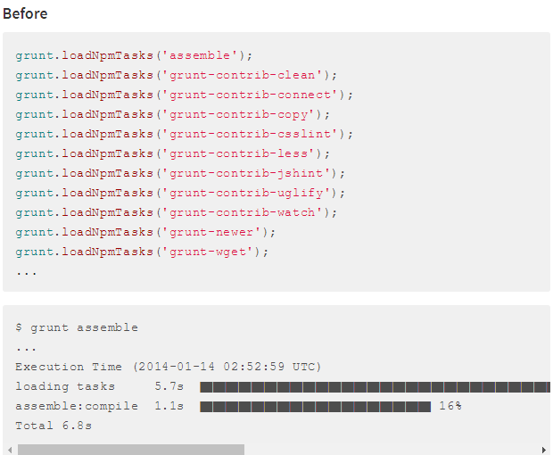

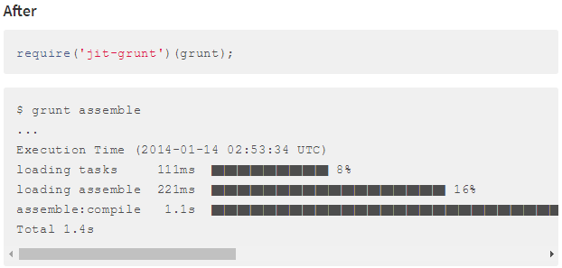

require(**'jit-grunt'**)(grunt, {  
 **useminPrepare**: **'grunt-usemin'**,  
 **ngtemplates**: **'grunt-angular-templates'**,  
 **cdnify**: **'grunt-google-cdn'**});

1. usemin replaces the references to scripts, stylesheets, and other assets within HTML files dynamically with optimized versions of them.
2. **'grunt-google-cdn'** Grunt task for replacing refs to resources on the [**Google CDN**](https://developers.google.com/speed/libraries/devguide).

**var** appConfig = {  
 **app**: require(**'./bower.json'**).appPath || **'app'**,  
 **dist**: **'dist'**};

1. Configuring the application path as appPath and build directory as dist.

grunt.initConfig({

… });

1. This defines the configuration for all the tasks
2. Watch- It watches for all task when any file is modified.